**Enumerate Function**

**Timing Your Code**

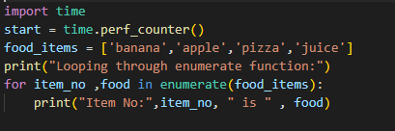

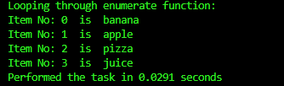

**User Inputs**

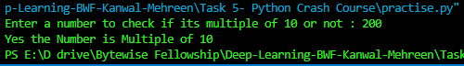

**Conditionals**

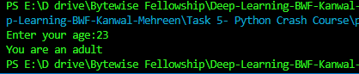

**Introducing Set**

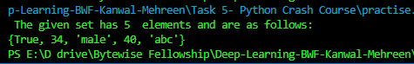

**Set Operations**

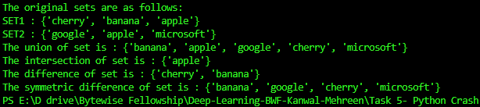

**Making Data Unique with Sets**

